1. **Purpose**
   1. This procedure describes the steps involved in and the responsibility of releasing an empty MgO Rail Car.
2. **Scope**
3. **Responsibility**
   1. Material Handlers and Lead Operators in their absence
4. **Safety Considerations**
   1. All safety glasses and appropriate safety apparel is to be worn at all times. Safety is a condition of employment. Employees are not authorized to work in an unsafe manner.
5. **Materials/Equipment**
   1. N/A
6. **Procedure**
   1. Follow the MgO Unloading Procedure for handling MgO cars – this Procedure is just for filling out the “MgO Car History Log”
   2. When an MgO car is spotted by the rail road, the Material Handler or designate is responsible for printing out a new MgO Car History Log for the car.
   3. Each MgO shall have its own log.
   4. All appropriate information is to be filled in before Hooking up a car for unloading. This information must include:
      1. The car number
      2. Time spotted
      3. Seal Number
   5. The car can then be sampled, hooked up and dumped following the MgO Unloading procedure.
   6. If the operator is unable to finish dumping car during their shift, the next shift takes over on the log, initialing beside each section they are responsible for.
      1. Each section MUST be initialed by responsible person.
      2. The amount in the car shall be checked each Morning at 07:00
   7. If there are issues with a car it is the responsibility of the Operator to fill out all information involved with the car on the MgO Car history Log. This will be the only record of problems or issues with this car.
   8. Once the car is finished unloading and all appropriate measure have been made, the Material Handler or Lead Operator is to sign the log stating:

“I have physically looked in this MgO car and declare it empty and ready to return”

**\* When signing this statement Operators are taking responsibility for this car.**

6.9 Operators are to notify Plant Manager or designee that the car is ready and completed log is to

be placed with all other completed shift work logs to be picked up and filled by Quality

department.

SAMPLE LOG SHEET

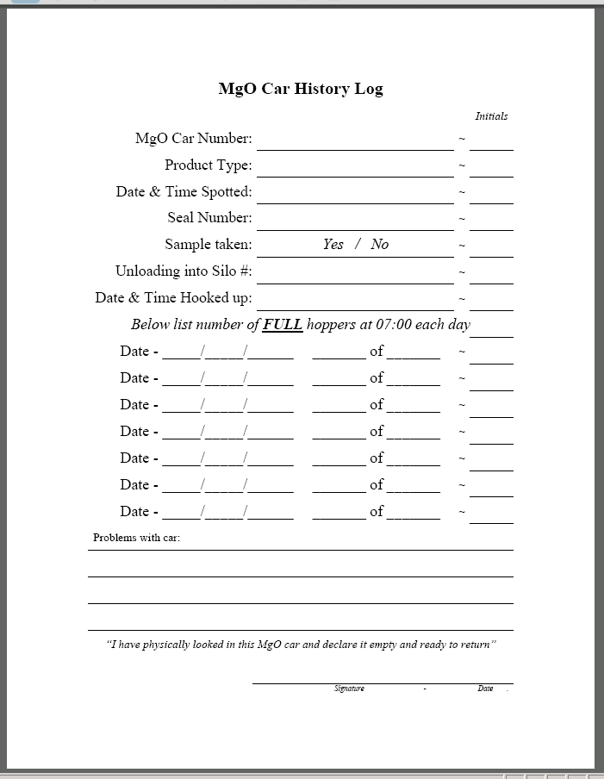

Operator must initial each blank that they fill in.

Circle Yes or No and initial when sample is taken

**5 of 5 means**

5 full hoppers of a 5 hopper car

**3 of 5 means**

3 full hoppers of a 5 hopper car

**1 of 4 means**

1 full hopper left on a

4 hopper car

This may run into another shift. Only put information and initial beside what you are responsible for

Write down any problems or issues you have with the car. This is the only way we can track car problems

When car is finished dumping, car is unhooked and checked the Operator is to sign official release of the car.

This signature is stating Operator takes responsibility or ownership for releasing this car as empty.

1. Reference Documents
   1. MgO Unloading Procedure
   2. MgO Car History Log

1. Amendment Record

|  |  |  |  |
| --- | --- | --- | --- |
| Revision  Number | Revision  Date | Revision  Author | Revision Description |
| 0 | 03/30/08 | JB | New Document |